Graded Unit 2 Inception Phase

Max Ritchie - 545737

BCSC2/FK

Forth Valley College

Contents

Project Brief 2

1. Stage One – Planning 3

1.1. Interpretation of The Project Assignment Brief 3

1.1.1. Analysis of the Project Assignment Brief 3

1.1.2. Solution One 4

1.1.3. Solution Two 4

1.1.4. Solution Three 4

1.1.5. Chosen Solution 6

1.2. Requirements 7

1.2.1. Functional Requirements 7

1.2.2. Non-Functional Requirements 8

1.3. Initial Top-Level Use Case Model 9

1.4. Information Gathering 10

1.4.1. Meeting with Client and Questionnaire 10

1.4.2. Background Research on Similar Websites 13

1.4.3. Background Research on Invoices 14

1.4.4. Background Research and Concept Ideas for The Company Logo 15

1.5. Project Aims 16

1.6. Identification of Resources and Materials 22

1.6.1. Hardware Requirements 22

1.6.2. Software Requirements 23

1.6.3. Books, Journals and Tutorials 26

1.6.4. Additional Resources 26

1.7. Identification of Information Sourced 27

1.7.1. Hardware References 27

1.7.2. Software References 27

1.7.3. Other Resource References 28

2. Stage Two – Project Plan 29

2.1. Project Deliverables 29

2.2. Project Screenshots 30

# Project Brief

Scenario Two - A Small Business System

You have been sent a proposal, which has you develop a small business application for the company Acquiesce Industries who deal with the selling of music, music merchandise and music memorabilia. The company will have you create a sales invoicing and stock control system suitable for a typical smaller retailer operating within the UK. The application should produce a sales invoice for every transaction and update of stock in real time with the use of a database.

There should be access to multiple different reports that need to be generated, detailed reports of daily, weekly, monthly and annual sales analysis, stock turnover and profit. There should also be reports dealing with stock including reorder reports for certain items and stock outages. Information of customers, suppliers, products and invoice information which includes transaction logs should be available only through employee access.

The system must include a database which will be used to store all stock. The database must be accessible to employee and admin users only to be able to add and remove stock when required. The products name, price, quantity/units and total units sold must be present within the database.

The company are looking for an app that is attractive, friendly and professional looking, going along with the standard requirements to all users, with an interface that is easy to understand and use along with complying with recognized standards. The company are expecting a top-level use case design to be created and presented within the next two weeks.

The application should be compatible to run on different platforms using minimum specs required. The application can either be created with a console-based interface (Text based) or a GUI (Graphical User Interface).

# 1. Stage One – Planning

## 1.1. Interpretation of The Project Assignment Brief

### 1.1.1. Analysis of the Project Assignment Brief

I have been approached by a company be the name of Acquiesce Industries, who are a small business that solely runs within the UK that deals with the selling of music items, such as music (CDs and Vinyl records), merchandise (such as clothing) and memorabilia. They have assigned me the task of creating an invoicing system that will be implemented within a shopping application. The company has asked for a database to be created along with the invoicing system, the database is required to hold all stock that the company current has to offer and the information of both customers and employees. With the use of the database, the company has asked that it is used to generate various reports, these reports include the sales (daily, weekly, monthly and annual) of stock and admin reports to show all completed orders with the use of parameters (date ranges). The company does not required reports to be saved but has asked for the ability to print out paper copies.

The company has asked that all products that are to be sold are to be displayed within one of three categories: music merchandise and memorabilia. Each item should be displayed by an image of the product along with details of the product, to acquire more information or to buy the product, the user is required to click on the product which will display additional details.

The company has issued the fact that the application must have a friendly and attractive look, but also to stick along-slide looking professional. They have also stated that the application is to be aimed more towards the age range if 15 to 35 with a fresh and funky look. A free scope has been given for the design and look of the application, the only constraints that have been given is not to include the colours red and blue heavily throughout the application. This has been applied to help with users that may have trouble with their sight. The application has been required to be easy to understand and navigate for users that may not be used to buying products through an application, having a clean professional layout with easy to read text is what has been asked for.

The company want the application to be run on computers with low specifications that have windows 7 or higher. They have stated that the application can be text based or have a graphical interface but with the use of images that they wish to be implemented, the company are pointing into the graphical interface direction.

### 1.1.2. Solution One

My first solution option would be to build a console-based application that will have the ability to link to a database that will be used to store all required company information. With a simple looking console interface that would only allow the user to type.

Advantages  
An advantage of creating a console based-application would be that, creating and building the application would take less time than creating and designing a graphical user interface. Console based- applications are a lot easier to run, they require a lot less resources and will be able to be run a lot smoother on machines that have the lower specifications rather than trying to run a graphical interface.

Disadvantages  
The most obvious disadvantage of using a console-based application would be that it would not be visually appealing and there would no use of images. Creating a shopping application with no pictures of the products wouldn’t be a very good idea as the customer is only going to be able reading about what the product is and not being able to see what they are actually buying. A lot of users may be confused with using a console interface and may not know how to work the application as other applications and websites nowadays use a graphical interface.

### 1.1.3. Solution Two

The second solution that I came up with is to create and build a desktop application that uses graphical interface. The interface will be very simple and straight forward and will allow the user to communicate with the database that stores all the companies required information, using parameter sliders and dropdown menus instead of typing everything out.

Advantages  
The advantages of a graphical interface would help the user understand and easily navigate their way through the application with just having the click buttons and icons, also it makes the application a lot more visually appealing to use. With the application only being accessible on the machine its self and not online, it makes the application a lot more secure than the creation of a web-based application which may be more vulnerable. It is also a lot more portable that using a console-based application as it can be made into an executable file. With the use of graphics, certain aspects of validation will be quicker with option boxes and dropdown menus, unlike with a console application, where all validation will have to be hard codded.

Disadvantages  
Even though it will be more portable, some devices that have low specifications may not be able to run the application well or not even at all. Running the application on a low specification device might take a longer time to load and build the application when run. A graphical interface will also take time to design and create and will also take time to test to make sure everything works correctly.

### 1.1.4. Solution Three

The final solution that I came up with was to create and build a web-based application. The application would have a simple and easy to understand user interface that would have a database connected to the backend which would store all required company information.

Advantages  
Advantages for this solution would be that the application would be very easy to access as long as the current device that it is on is connected to the internet, other devices would be able to access it. The interface would be very similar to solution two, very simple and easy to understand with the use of graphics with clickable buttons and icons instead of typing out commands, provides a good user experience.

Disadvantages  
The main disadvantage to using the web is that if you do not have an internet connection, you are unable to use the application. Being online, the application may run slower since it’s accessed on the web rather than locally where I would run fast and smooth. There could be complications with users who are using different web browsers, not all web browsers may be compatible with the application. Another risk is security, being online, the database and application are at more of a risk than being stored locally where only the local device would have access to it.

### 1.1.5. Chosen Solution

I have thought and compared my three potential solutions with each other, and I have decided that I am going to go ahead and use Solution Two (1.1.3. Solution Two). I will be creating and building a desktop application using JavaFX. I am going to develop a windows-based application that will be able to be run on Windows 7 or above. I have decided to use JavaFX as my unfamiliar language to build the application and I will be creating a database from the ground up that will be compatible with the application. The database will be accessed by SQL within the application through a created interface that will be able to interact with data that will stored within the database.

The user interface is one of the most important parts of the application, with very specific requirements from the brief and client to have the layout and design to be easy to understand and easy to navigate. That is the one of the main reasons I chose this solution, I’m able to create a graphical interface that will make for a good user experience and understanding of how to use the application. I feel as though a console-based application would make it difficult for users to navigate the application and isn’t very visually pleasing as seeing text with images and icons that can be clicked instead of typing in commands. Majority of applications now have a graphical interface, it wouldn’t be right to create a console-based application which would take the average user out of their comfort zone. Another reason for a graphical interface is that it offers a wider variety of options on usability and looks than using a console which offers very little customizable options of how the application will look.

All reports that are to generated (sales, stock, employee info) will be set up by parameters that the user (employee) will set. The parameters will include a date range and a dropdown menu with different options that can be selected. These reports won’t be saved but will have an optional print button to print out paper copies.

After every transaction, an invoice will be generated and displayed to the customer. All invoices will be saved into the database where employees will have the ability to view them. Employees will have the option to view the invoices will the click of button through the employees account page.

The application will communicate to the database and pull the required information needed from it to be used such as display products. All information about a product must be pulled out of the database and displayed to the screen.

I have chosen Java to create to build the application is because I am very comfortable with using Java and is the most familiar language to me. I know there are features and packages in the Java library that I can implement and use to help build the application. Having used Java for a long period of time, I am able to take advantage of the wide range of packages and library functions that Java has to offer. Using a database with my application allows me to save all information required in the database, this ensures that no data will be lost when the application is not being used or is off.

## 1.2. Requirements

### 1.2.1. Functional Requirements

My functional requirements are showing what the application must do. I am going through each page that will be present and listing off what should be carried out to make the page work.

1. Creation and use of a database.
   1. Store all stock.
   2. Store all employee information.
   3. Store all customer information.
   4. Store all invoices generated.
   5. Real time stock update when items sold.
2. Display homepage.
   1. Display information about what the company sells.
   2. Display featured/promoted items.
   3. Drop down menus with links to other pages.
3. Display login page.
   1. Link to the sign-up page.
   2. Link to forgotten password.
4. Display user account page.
   1. Link to change users password.
   2. Display users order history.
   3. Return button linked to the homepage.
5. Display products pages.
   1. Display products with information and images.
   2. Clickable images to display additional information.
   3. Drop down menus with links to other pages.
6. Display single product page
   1. Add product to basket button.
   2. Back button to products page.
7. Display users basket page.
   1. Display all added products.
   2. Remove buttons that will remove items from the users basket.
   3. Checkout button linked to checkout page.
8. Display checkout page.
   1. Accept payment details.
   2. Display users delivery information.
   3. Confirmation button to confirm the order.
   4. Updates the database that items have been sold.
   5. Cancelation button that returns to the users basket page.
9. Display employee page
   1. Options to set parameters for reports.
   2. Generate report button.
   3. View invoices button.
   4. Print reports button.
   5. Edit button linked to edit database popup screen.
10. Display database edit screen.
    1. Add button to display input boxes for the user to add items to the database.
    2. Remove button to display a search box for the user to search the database for the item that is be removed.

### 1.2.2. Non-Functional Requirements

In my non-functional requirements, I am listing all the additional information/constraints that need to be followed to ensure that the system looks and runs correctly.

1. Free scope on design.
2. Recognized standards applied to the interface.
   1. Simple and easy to understand interface.
   2. Attractive, friendly and professional looking interface.
   3. No heavy use of colours that effect users with colour vision deficiency (blue and red).
3. Graphical interface.
4. Large use of images throughout the application.
5. Compatible for windows 7 and up.
   1. Device must be up to date.
   2. Requires minimum specs to run.
6. Database to be used
   1. Real time stock update.
7. Optional ability to print out reports.
8. Ability to set parameters for reports.
9. No budget allocated.
10. All reports must be layout out correctly.
11. Prototype of application required.
12. Top level use case design required in two weeks.

## 1.3. Initial Top-Level Use Case Model

Using Umlet, I created a top-level use case diagram to display the basic structure of how the application will work. I used the functional requirements along with their referenced number. At this stage, the diagram is very simple, only including the major functional requirements that make the application work. The diagram displays the employee side of the system and the user/customer side along with how the database is interacted with. The diagram of the system is shown below.

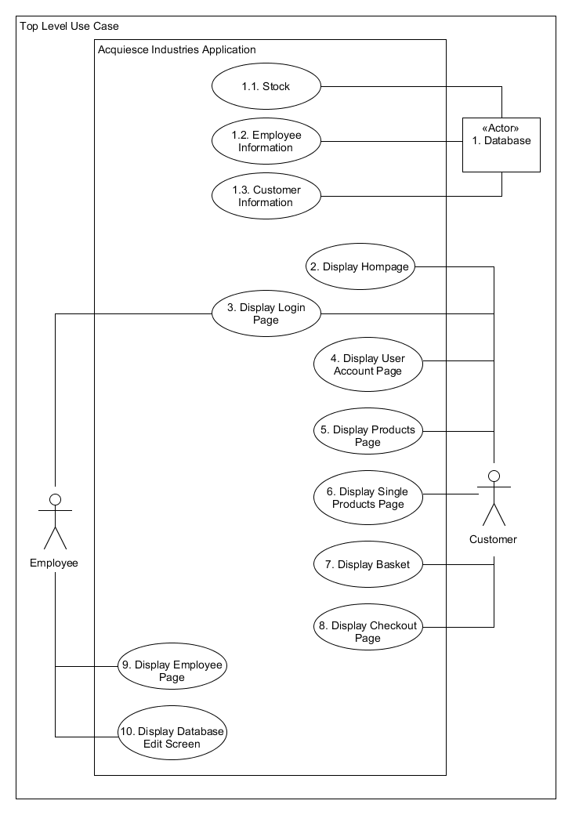

## 1.4. Information Gathering

### 1.4.1. Meeting with Client and Questionnaire

After reading the brief, I needed to obtain additional information. One of my methods of gathering additional information was a meeting with the client, I scheduled and conducted a formal meeting with the client in the morning of the 8th of February 2019. I had prepared a set of questions for the client to answer that would help confirm and clarify certain aspects of the brief and to get more detail on what the client wants. Here is a table that contains all the questions that were asked along with the answers that I received:

|  |  |  |
| --- | --- | --- |
| **No.** | **Question** | **Answer** |
| 1. | What is the budget assigned to the project? | There is no budget for this project. |
| 2. | What are the products/items that the store will be selling and need to be stored? | Three categories – music (CDs and Vinyl), merchandise (clothing), memorabilia:  Music   * Unique id * Artist * Genre * Year released * Price * Tracks * Quantity * Name   Merchandise   * Unique id * Size * Price * Quantity * Name   Memorabilia   * Unique id * Price * Name * Quantity |
| 3. | Is there any specific layout of how you would like the generated reports to look like? | Same as the sample invoice, also include 20% VAT. |
| 4. | Having employee accounts, will there be any other accounts that need to be created, and if so, what rights/permissions do these accounts have. | All employee accounts should be admin accounts:  Admin accounts   * All the same user rights. * Details – id, name, username, passwords * Concatenate username – first three letters of first name with generated number at the end. |
| 5. | Who is the target audience and what is the age range? | Between 15 to 35, got to look fresh and funky, no reds or blues colours to be used. |
| 6. | Is there any theme (certain colours or layouts) that needs to be followed? | Free scope. |
| 7. | How will payment for products be implemented/accepted and stored? | Credit/debit card payments. |
| 8. | How would you like products to be displayed to the user? | Image of product, along with information. More information shown when clicked on. |
| 9. | What platforms should the application be compatible with and what are the minimum requirements/specs to be able to run the application? | Must be windows 7 and up. |
| 10. | Does the device that the application is being used on must be up to date for it to work properly? | Yes, they must be the latest version. |
| 11. | Are there any additional details that need to be stored for products? | Description for product when clicked on. |
| 12. | Is there any other reports or additional details to existing reports that needs to be added or generated? | The ability to generate reports that:   * Select a date range * Select most popular products for each category * Admin reports, who made the most orders * How much stock is present within each category |
| 13. | Will customer information also be held within the database or is there an alternative storage space reserved for this information? | Held within the database, all information must be valid before being stored, information on customers being sold:   * Unique id * First name * Last name * Email address * Home address * Phone number |
| 14. | Does the application have anything online that links to the app? | Nope, not required for the first stage. |
| 15. | Having the reports generated digitally, would you like the option to be able to print out paper copies? | Yes, print screen capture at this current stage. |
| 16. | Do the reports have to be saved, if so how and where would the reports be saved? | Reports would not be saved. Invoices would be saved instead for customer orders, these will be saved in the database. |
| 17. | How would you like to access the database and the ability to add and remove stock? | An edit/add and remove product screen along with dropdown menus for each product category. |
| 18. | Will there be only one database where everything is store or will there be multiple databases for different sets of information (employees and stock info)? | Only one database required for all information. |

### 1.4.2. Background Research on Similar Websites

I needed to find ideas on what the application will look like, my other form of information gathering was to look at different websites that deal with the selling of music. I visited various websites to see what their take on selling CDs looked like. The one that I thought looked the best was amazon.co.uk. as the layout of the music is like what the client intended. They also have the feature of clicking on the image of the CD to reveal more information and the option to add the item to your basket. This design is very similar to what the client has asked for and I will be basing the overall application design on this. The website also displayed different music categories of music genres, I thought this could fit well with what the client has described but may need to discuss and clarify this with the client in a future meeting. The reference to this website is listed within section 1.7.3, the layouts of music are shown in the screenshots of the website below.

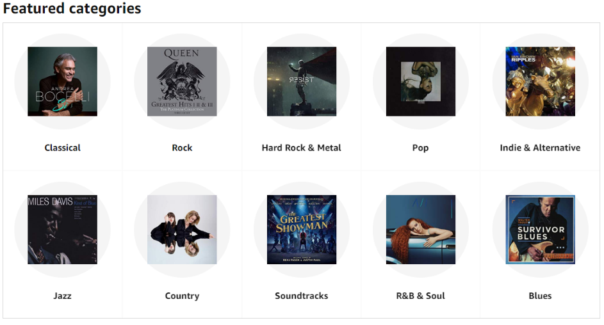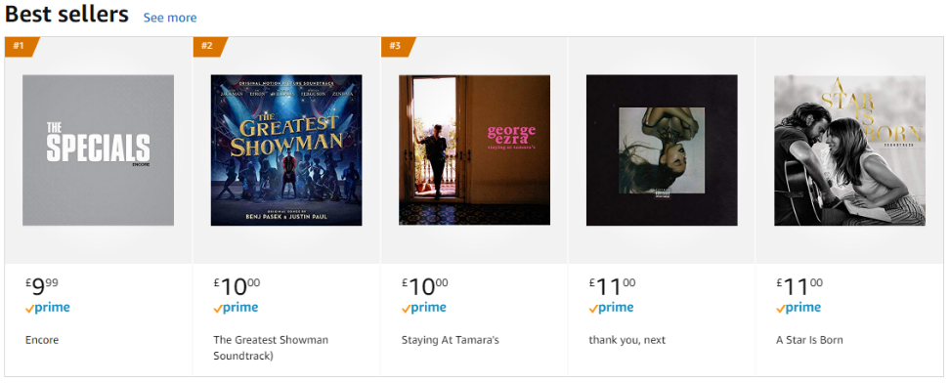

(Amazon, 2019)

I also found another two websites that I like the look of, the first being hive.co.uk and hmv.com, even though HMV do not have an online retailer, I like the layout of how the menus look and are interacted with. This is a similar style that I had in mind of the application. Hive.co.uk has a very similar layout to Amazon, also with having the music categorized by genre. This and amazon’s layout are what I am going to use to base and create my design for the application. With the use of the HMV styled menus, I think it will work well with the other music layouts. The references for these webpages are listed in section 1.7.3, the screenshots of HMV’s menu layout and Hive’s music layout are shown in the screenshots below.



(HMV, 2019)

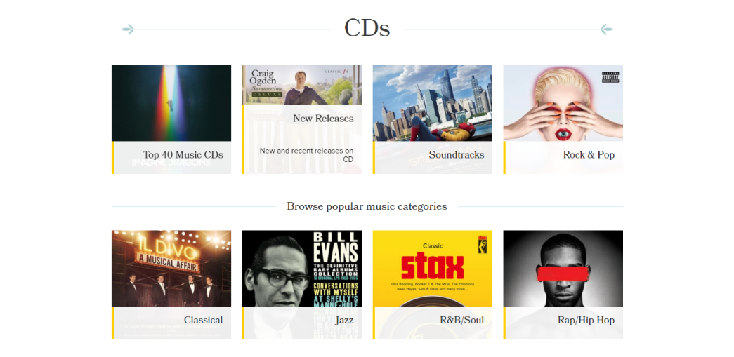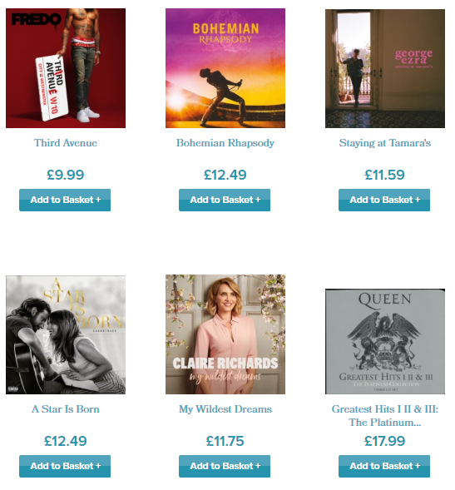

(Hive, 2019)

### 1.4.3. Background Research on Invoices

In the meeting with the client, they discussed that they were very happy to have the same layout as the sample invoice example that was provided. I will be using the same layout as the sample invoice but will be changing the style to match what the application will look like.

This what the customer will be when they purchase an item(s) from the application. Employees will also be able to view all invoices through their accounts. The displayed invoices that the employees get to view will be the exact same as what is displayed to the customer.

### 1.4.4. Background Research and Concept Ideas for The Company Logo

|  |  |
| --- | --- |
| Research  After doing research on various logos from different brands, I wanted to logo to be simple, not too much detailed but just enough to catch the eye of the user. I selected the H&M logo to base the logo around. The idea of only using the initials of the company looks very simple and slick.  Font Used: Manus |  |
| Version One  For the first design I put the initials vertically onto each other with a white line between each the characters. This was my initial thought for the logo, but it did not stand out as much as I wanted it too.  I used the colours red and white with the chosen font as it suited what a music themed store would look like, it gives it a rock and roll look too it. |  |
| Version Two  I changed the positions of the characters to be horizontally aligned to each other separated with the white stripe. I think having the logo this way makes it stand out a lot more and more appealing to the eye.  This version is very simple and may even be what the final outcome of the logo may look like. |  |
| Version Three (Final Concept Version for Now)  This is the final version of the logo that I came up with. I kept adding onto the previous copies to create this.  Adding the red underline makes the logo standout even more than the previous versions. The only problem with having it, it might be a little too much detail added to the logo, but this is only the first concept versions of the logo and are subject to change further along the line. |  |

## 1.5. Project Aims

The main aim of this project is to build a fully working prototype of the application before the deadline of the 24th of May 2019. The application must meet all requirements that have been specified within the brief, functional and non-functional requirements. The prototype will contain all working functional aspects that have been discussed.

The applications prototype will have a created colour scheme that will be followed throughout the application as a free scope on layout and design as been given for the project. The interface that will be presented will match all requirements that were set by the client, being very easy to understand and navigate. With the use of a database for the stock, the application will be able to communicate back and forward with it, checking and updating stock in real time. The application will have the ability to notify an employee user of stock running low when the unit of stock hits a certain number, which will trigger the notification message. The application will also have the ability to display a wide range of information about customers, employees, invoices and products that are currently being stored within the database.

The prototype will generate and produce invoices and reports with the use of the database. The invoices will be generated after a transaction has been completed by a customer and saved into the database, where employees will have the ability to access them. The reports that will be generated only through an employees account with the use of parameters to select what is to be generated. These reports will have the option to be printed out to paper copies.

1.5.1. Application Prototype  
I have used the online resource of Moqups (Moqups, 2019) to create a stage one prototype of what the application will be look like and how it will function. Each page that contains a menu bar with certain options, each option displayed within the menu bar is clickable and will take the user to the corresponding page. The image/company logo in the top left-hand corner of each page can be used as a home button that will take the user back to the homepage, no matter what page they are currently on. When a user has logged into the system, the login/register button in the menu bar will change to log out. When clicked the user currently logged in will be logged out of the system and the button will be returned to its original state of login/register.

Below are screenshots of what each page will look like, this is only a first version so it may change slightly in the future.

|  |  |
| --- | --- |
| Homepage  This is what the homepage may look like. A very simple and easy to understand layout. I have included a dropdown menu for music, to distinguish CDs from Vinyl into different music genres.  Another idea I thought of would have featured, best selling or new music being displayed. This would be the first page the user would see when the application is loaded up. |  |
| Homepage with Colour  I made another version of the homepage but with colour and images. This is an idea of what the overall application colour scheme may look like. I also created and implemented a logo the company can use. |  |
| Merchandise and Memorabilia Product Page  This is what the customer will see when they click on the Merchandise or Memorabilia menu tab. All products are displayed with an image, its name and a small detailed description about it. When the user clicks on the name or the image of the product it will take them to the products own page with more information and the option to add it to their basket.  Each item will be laid out evenly with one item at one line at a time. Using a scroll bar to browse all items. |  |
| Music Page  This is what is shown when the music tab for CD or Vinyl is clicked. Same as the homepage, this page will display the featured, best sellers or new albums at the top of the screen, making it the first thing the user sees.  All images and titles will be clickable, taking the user to the genre page if one of the genres is clicked or to the albums page.  The layout for each image on the page will be even, making it easy on the eye to look at, instead of it looking messy and unorganized. |  |
| Genre Page  The genre page will display all current genres that are stored within the database. Each title and image, when clicked on will take the user to that genres page. That page will have the same look and layout as the music page but only to the one genre. |  |
| Single Item Page  This page will be displayed when a product has been clicked. This is the page where the user can receive extra information on the product and the option to add it to their basket.  Adding items to your basket will update the basket button in the menu bar to the number of items currently being held in the basket. |  |
| Users Basket Page  Any item that the user has added to their basket will appear here. The user has the option to carry on and checkout with these items or they have the option to remove them.  When the user clicks the remove item button, that item will be removed from the users basket and the basket counter in the menu bar will update to the number of items currently held with the users basket. |  |
| Login Page  The login page will be used by customers and employees but will show different pages when logged in. Employees will be shown their accounts page first and customers will be directed to the homepage.  The forgotten password will display a screen that will allow the user to change their password. |  |
| Customer Account Page  This page will be displayed when a customer selects the account button in the menu bar. The customer will to view their account details, their order history and the ability to change their password. |  |
| Employee Account Page  The is the page that will be displayed when employees sign into the system. They can also change their password, but they can also view all invoices for sales and generate reports using certain parameters if required.  The edit database display pop us that allow employees to add or remove items from the database. |  |
| Edit Database Pop up  The edit database screen pops up when an employee clicks the edit database button on their account page. There will only be two options on this screen – add or remove. These two buttons will pop up their corresponding pop ups. |  |
| Add Item Pop up  This page allows the employees to add items to the database, each box is mandatory and must be filled before the add button can be clicked. |  |
| Remove Item Pop up  The remove page allows the employee to search for an item within the database using its unique identifier. The items information will be displayed to the screen and the employee has the option to remove that item or cancel the action. |  |

1.5.2. Logo Creation

With the free scope of the project, I decided to create a logo for the company. I did this to provide extra detail for the prototype to make it look and feel more realistic and give it more style. I have only created a concept design that will be worked on in the future after discussing potential changes that could be made with the client. Here is the final (of the concept designs) design that I came up with that I will present to the client. My research and other concept ideas are shown and discussed in section 1.4.4.

## 1.6. Identification of Resources and Materials

For me to begin this project, I require to have a suitable computer/device that is adequate to run my required software. I have researched and found a suitable desktop that can run the software. I have chosen **windows 10** as my operating system for my PC. My reasoning for my choice is that windows 10 is the newest/ most up to date software out at the current time. Also, most software is compatible with windows 10 and can be run (**Eclipse, Java FX, Microsoft Project, etc**). With the desktop PC, it requires a monitor, mouse and keyboard. I selected a standard monitor that is big enough to work with and a standard hp mouse and keyboard. I have also chosen to get a printer to help with the testing as the application will need to be tested for the implemented printing feature, I have selected a standard printer that can print in colour and black and white. I have also included a USB that will used to transfer prototypes to present to the client.

**JavaFX** – I chose JavaFX because I have a good knowledge and understanding with Java in general and I know that Java is a well-known programming language. I have also never used FX before so it will be a new learning experience for me (my choice for an unknown language).

**Microsoft Project** – I will be using project to crate my timescale for the project. With the use of a Gantt chart, this will hep me keep time with certain tasks and areas to work on.

**Moqups** – Using moqups, I am able to create a stage one prototype of what the application may look like and have working links to make it functional, allowing the client to have a look and feel of what the applications functoriality may be like.

**Paint.net -** I will be using this for creating logos and designs for the layout and design of the application. I chose this piece of software because I have used it in the past and I am very confident in using it.

**phpMyAdmin** – I will be using phpMyAdmin to create and build the required database. This will hold al stock, employee, customer information along with saved invoices. All information stored within this database will be saved and insure that no data is lost when the application is off and not running.

**UwAmp** - I will be being using UwAmp to act as a local server host to allow the database to be run and accessed.

All my references for my hardware and software are in sections 1.7.1 and 1.7.2.

### 1.6.1. Hardware Requirements

|  |  |  |  |
| --- | --- | --- | --- |
| **Hardware** | **Device Specifications** | **Additional Cost** | **Source** |
| HP Pavilion Desktop PC | * Every day: All-rounder for work and play * AMD A9-9425 Processor * RAM: 8 GB / Storage: 1 TB HDD | £379.00 | (PCWorld, 2019) |
| HP ProDisplay P223 21.5” FHD Monitor | * Free USB Port Tilt range -5° to + 22° vertical * Full HD (1920x1080) Display * Anti-glare, 54.6cm (21.5”) Display * 1 VGA; 1 DisplayPort 1.2 (with HDCP support) | £110.40 | (HP, 2019) |
| HP Envy 4500 Printer | * RAM size: 32MB * Connectivity: USB 2.0, Wireless LAN * Thermal Inkjet * Ink colour: Assorted | £194.99 | (Amazon, 2019) |
| HP 3-button USB Laser Mouse | * Free USB Port * Minimum requirements: Windows Vista, Windows 7 | £15.60 | (HP, 2019) |
| HP USB Slim Business Keyboard | * Free USB Port * QWERTY Key layout | £21.78 | (HP, 2019) |
| SanDisk Ultra USB Flash Drive | * Size: 64GB * USB 3.0 enabled * Free USB Port | £12.69 | (Amazon, 2019) |
| **Hardware Total Cost: £734.46** | | | |

### 1.6.2. Software Requirements

|  |  |  |  |
| --- | --- | --- | --- |
| **Software** | **Required Specifications** | **Additional Cost** | **Source** |
| Windows 10 Home – Version 1803 | * Processor: 1 gigahertz (GHz) or faster processor or SoC. * RAM: 1 gigabyte (GB) for 32-bit or 2 GB for 64-bit. * Hard disk space: 16 GB for 32-bit OS 20 GB for 64-bit OS. * Graphics card: DirectX 9 or later with WDDM 1.0 driver. * Display: 800x600. | £119.99 | (Microsoft, 2019) |
| Eclipse ide Photon June 2018 | * 1 gigabyte (GB) RAM (32-bit) or 2 GB RAM (64-bit) 16 GB * available hard disk space (32-bit) or 20 GB (64-bit) * Java version 1.4.0 * Memory: 512MB * Free disk space: 300MB * Processor speed: 800Mhz | Free | (Eclipse, 2018) |
| JavaFX | * Memory: 512MB * Disk space: 778MB * Web browsers: Internet Explorer 6 minimum, Firefox 3.0 minimum * Java SE Development kit (JDK): JDK 6 Update 13 minimum * Windows XP with Service Pack 2 or Windows VistaMac OS X 10.4.10 minimum | Free | (Java, 2019) |
| Microsoft Project 2013 Professional | * 1 gigabyte (GB) RAM (32-bit) or 2 GB RAM (64-bit) 16 GB * available hard disk space (32-bit) or 20 GB (64-bit)   1 Ghz or faster x86-bit or x64-bit processor with SSE2 instruction set   * Memory: 2GB RAM * Hard disk space: 3GB * Windows only | £49.99 | (Brytesoft, 2019) |
| Umlet | * 1152 x 864 screen resolution * Dedicated OpenGL-compliant graphics card * 2Ghz+ Intel Pentium / AMD Athlon CPU. * RAM: 2GB. | Free | (UML, 2019) |
| Moqups | * Internet connection | Free | (Moqups, 2019) |
| Google Chrome | * Internet Connection * Windows 7, 8, 8.1, 10 or later. * Pentium 4 processor or later that's SSE2 capable. | Free | (Google, 2019) |
| Paint.net | * Windows 7 or higher. * .NET Framework 4.7.1. * 1GHZ processor. * RAM: 1GB. * Hard disk space: 200MB. | Free | (Paint.net, 2019) |
| UwAmp | * Internet connection. * Windows XP or greater. * RAM: 512MB. * Hard disk space: 200MB. | Free | (UwAmp, 2019) |
| phpMyAdmin | * RAM: 4GB | Free | (phpMyAdmin, 2019) |
| **Software Total Cost: £169.98** | | | |

|  |
| --- |
| **Overall Total Cost: £904.44** |

### 1.6.3. Books, Journals and Tutorials

|  |  |  |
| --- | --- | --- |
| **Tutorial** | **Reasoning** | **Source** |
| W3Schools SQL | With the use of a database in the application I am going to need to learn how to use SQL and learn all the required commands that are going to be used. (w3schools, 2019) | (w3schools, 2019) |
| Microsoft Project | Having used Microsoft project in the past, I have a good understand on some of the basics of it. With a tutorial on how to set up and correctly use it will help with the creation of my timescale for the project. (Campbell, 2017) | (Campbell, 2017) |
| YouTube | I may need to watch tutorials on how to achieve certain things if I cannot find anything on the web or if I am struggling to understand from just reading. | (YouTube, 2019) |
| Stack Overflow | Using a new programming language, I may need to look for hep and solutions on how to do carryout certain tasks. | (StackOverflow, 2019) |

### 1.6.4. Additional Resources

|  |  |
| --- | --- |
| **Resource** | **Reasoning** |
| Notepad | Used to take notes with meeting with the client. Note down ideas when I’m not at or using the computer. |
| Pens | Need to have pens to be able to write down everything, for notes and meetings. |
| Mobile Phone/Recorder | I may use this to record meetings with the client. |

## 1.7. Identification of Information Sourced

### 1.7.1. Hardware References

Amazon, 2019. *amazon.co.uk - HP Envy 4500 e-All-In-One Printer - Black.* [Online]   
Available at: https://www.amazon.co.uk/HP-Envy-4500-All-Printer/dp/B00DUVN28S  
[Accessed 11 02 2019].

Amazon, 2019. *amazon.co.uk - SanDisk Ultra USB Flash Drive USB 3.0 up to 100 MB/s - Black, 64GB.* [Online]   
Available at: https://www.amazon.co.uk/SanDisk-Ultra-USB-Flash-Drive/dp/B00DQGBYDC/ref=sr_1_1?s=computers&ie=UTF8&qid=1550074049&sr=1-1&keywords=usb  
[Accessed 11 02 2019].

HP, 2019. *hp.store.com - HP USB Slim Business Keyboard.* [Online]   
Available at: https://store.hp.com/UKStore/Merch/Product.aspx?id=N3R87AT&opt=ABU&sel=ACC  
[Accessed 11 02 2019].

HP, 2019. *store.hp.com - HP 3-button USB Laser Mouse.* [Online]   
Available at: https://store.hp.com/UKStore/Merch/Product.aspx?id=H4B81AA&opt=&sel=ACC  
[Accessed 11 02 2019].

HP, 2019. *store.hp.com - HP ProDisplay P223 21.5" FHD Monitor.* [Online]   
Available at: https://store.hp.com/UKStore/Merch/Product.aspx?id=X7R61AT&opt=ABU&sel=MTO  
[Accessed 11 09 2019].

PCWorld, 2019. *pcworld.co.uk - HP Pavilion 590-a0017na AMD A9 Desktop PC - 1 TB HDD, Black.* [Online]   
Available at: https://www.pcworld.co.uk/gbuk/computing/desktop-pcs/desktop-pcs/hp-pavilion-590-a0017na-amd-a9-desktop-pc-1-tb-hdd-black-10182117-pdt.html  
[Accessed 11 02 2019].

### 1.7.2. Software References

Brytesoft, 2019. *uk.brytesoft.com - Microsoft Project 2016 Professional.* [Online]   
Available at: https://uk.brytesoft.com/microsoft-project-2016-professional.html?gclid=EAIaIQobChMIhL3Ow5e54AIVzLftCh3NjwieEAQYASABEgLug_D_BwE  
[Accessed 02 11 2019].

Eclipse, 2018. *eclipse.org - Eclipse Photon.* [Online]   
Available at: https://www.eclipse.org/photon/  
[Accessed 11 02 2019].

Google, 2019. *google.com - Download Google Chrome.* [Online]   
Available at: https://www.google.com/chrome/   
[Accessed 11 02 2019].

Java, 2019. *openjfx.io - JavaFX 11.* [Online]   
Available at: https://openjfx.io/  
[Accessed 11 02 2019].

Microsoft, 2019. *microsoft.com - Windows 10 Home (Download).* [Online]   
Available at: https://www.microsoft.com/en-gb/p/windows-10-home/d76qx4bznwk4/1NT3  
[Accessed 11 02 2019].

Moqups, 2019. *moqups.com - Online Mockup, Wireframe & UI Protoyping Tool.* [Online]   
Available at: https://moqups.com/  
[Accessed 11 02 2019].

Paint.net, 2019. *getpaint.net - Download Paint.net.* [Online]   
Available at: https://www.getpaint.net/download.html  
[Accessed 11 02 2019].

phpMyAdmin, 2019. *phpmyadmin.net - Download phpMyAdmin.* [Online]   
Available at: https://www.phpmyadmin.net/   
[Accessed 11 02 2019].

UML, 2019. *UML - Free UML Tool for Fast UML Diagrams.* [Online]   
Available at: https://www.umlet.com/  
[Accessed 11 02 2019].

UwAmp, 2019. *UwAmp - Download UwAmp.* [Online]   
Available at: https://www.uwamp.com/en/  
[Accessed 11 02 2019].

### 1.7.3. Other Resource References

Amazon, 2019. *amazon.co.uk - CDs & Vinyl.* [Online]   
Available at: https://www.amazon.co.uk/music-rock-classical-pop-jazz/b?ie=UTF8&node=229816  
[Accessed 11 02 2019].

Campbell, S., 2017. *Microsoft Project Instruction Notes,* Falkirk: Shirley Campbell.

Hive, 2019. *hive.co.uk - CDs.* [Online]   
Available at: https://www.hive.co.uk/Music  
[Accessed 11 02 2019].

HMV, 2019. *hmv.com.* [Online]   
Available at: https://www.hmv.com/  
[Accessed 11 02 2019].

StackOverflow, 2019. *stakcoverflow.com - Top Questions.* [Online]   
Available at: https://stackoverflow.com/  
[Accessed 11 02 2019].

w3schools, 2019. *w3schools.com - SQL Tutorial.* [Online]   
Available at: https://www.w3schools.com/sql/  
[Accessed 11 02 2019].

YouTube, 2019. *youtube.com - YouTube.* [Online]   
Available at: https://www.youtube.com/  
[Accessed 11 02 2019].

# 2. Stage Two – Project Plan

## 2.1. Project Deliverables

I have listed all project deliverables within the report, as I was unable to add then into my project plan, as Microsoft Project did not allow me to use this feature. However, I will also be using my milestones in my plan to act as deliverables. I have also giving my-self some extra spillage days for any required remediation.

**Documentation for Initial Meeting with the Client – 8th of February 2019**I produced two sets of documentation to be presented to the client, a brief along with a short questionnaire. I conducted an interview with the client to obtain a grater understand of the task in hand, my questionnaire for the client will allow me to obtain in depth details and a clear understanding of what is being asked from them within the brief.

**Stage One – Planning – Inception Phase Report for 15th of February 2019**  
In this report I will discuss my solutions along with a detailed interpretation of the given brief. I will be listing of all requirements (functional and non-functional) on what the application should contain/do. It will also contain all research that I intend to do to help me with future activities that I will carrying out along with all the necessary equipment I need to begin the project. A top-level use case diagram will be produced here using the functional requirements to display a basic structure of how the application will work.

**Solution Planning Phase Report – 26th February 2019**A more in depth and detail use case diagram will be produced in this report which will also include sub diagrams for my use cases along with use case descriptions. These descriptions will show/describe how each use case will work/function. An erd will be produced here to display how the data base will look and how it will be laid out. The final designs on what the user interface will also be produced and presented within this report.

**Stage Two - Development Phase – 30th April 2019**This report will include information on how the creation of the application went, with all the different testing that was performed and the testing documentation that was produced. Also, this report will contain all java docs that will be produced after completion.

**Stage Three - Evaluation Phase Report – 21st May 2019**In this stage, my evaluation report will be about how the overall project went. I will go into the details of how project look at end of the process and compare it to the original plans. I will be assessing my own strengths and weaknesses that I encountered throughout the development process. There will also be an in-depth summary of what changes that were made during the development process, I will be listing and discussing all changes, why those changes were made and the benefit of the changes after being applied. Any problems that I encountered will be discussed and my solution to solving the problem. I will be ending my evaluation with what I could have done to improve the project process if I were to do it again.

## 2.2. Project Screenshots

